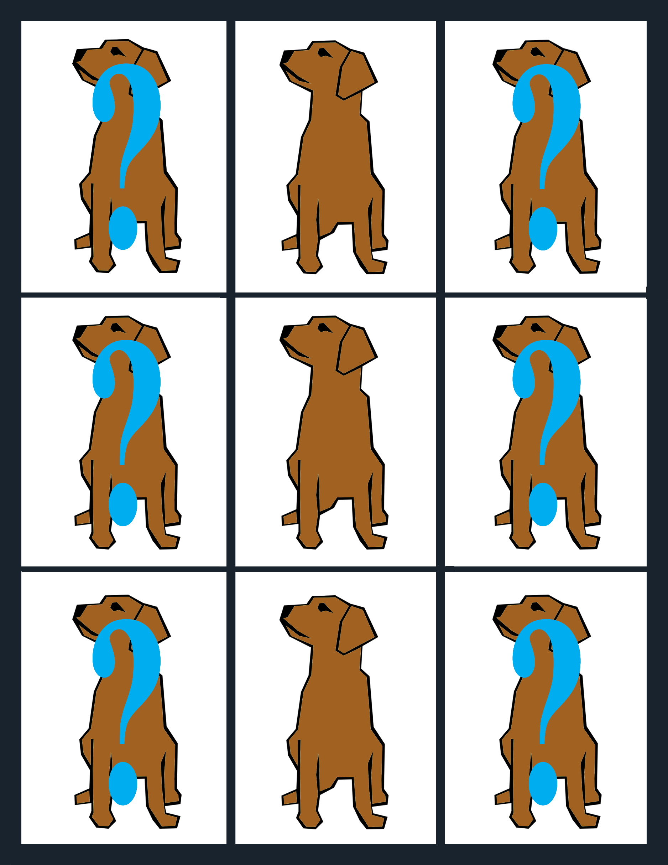
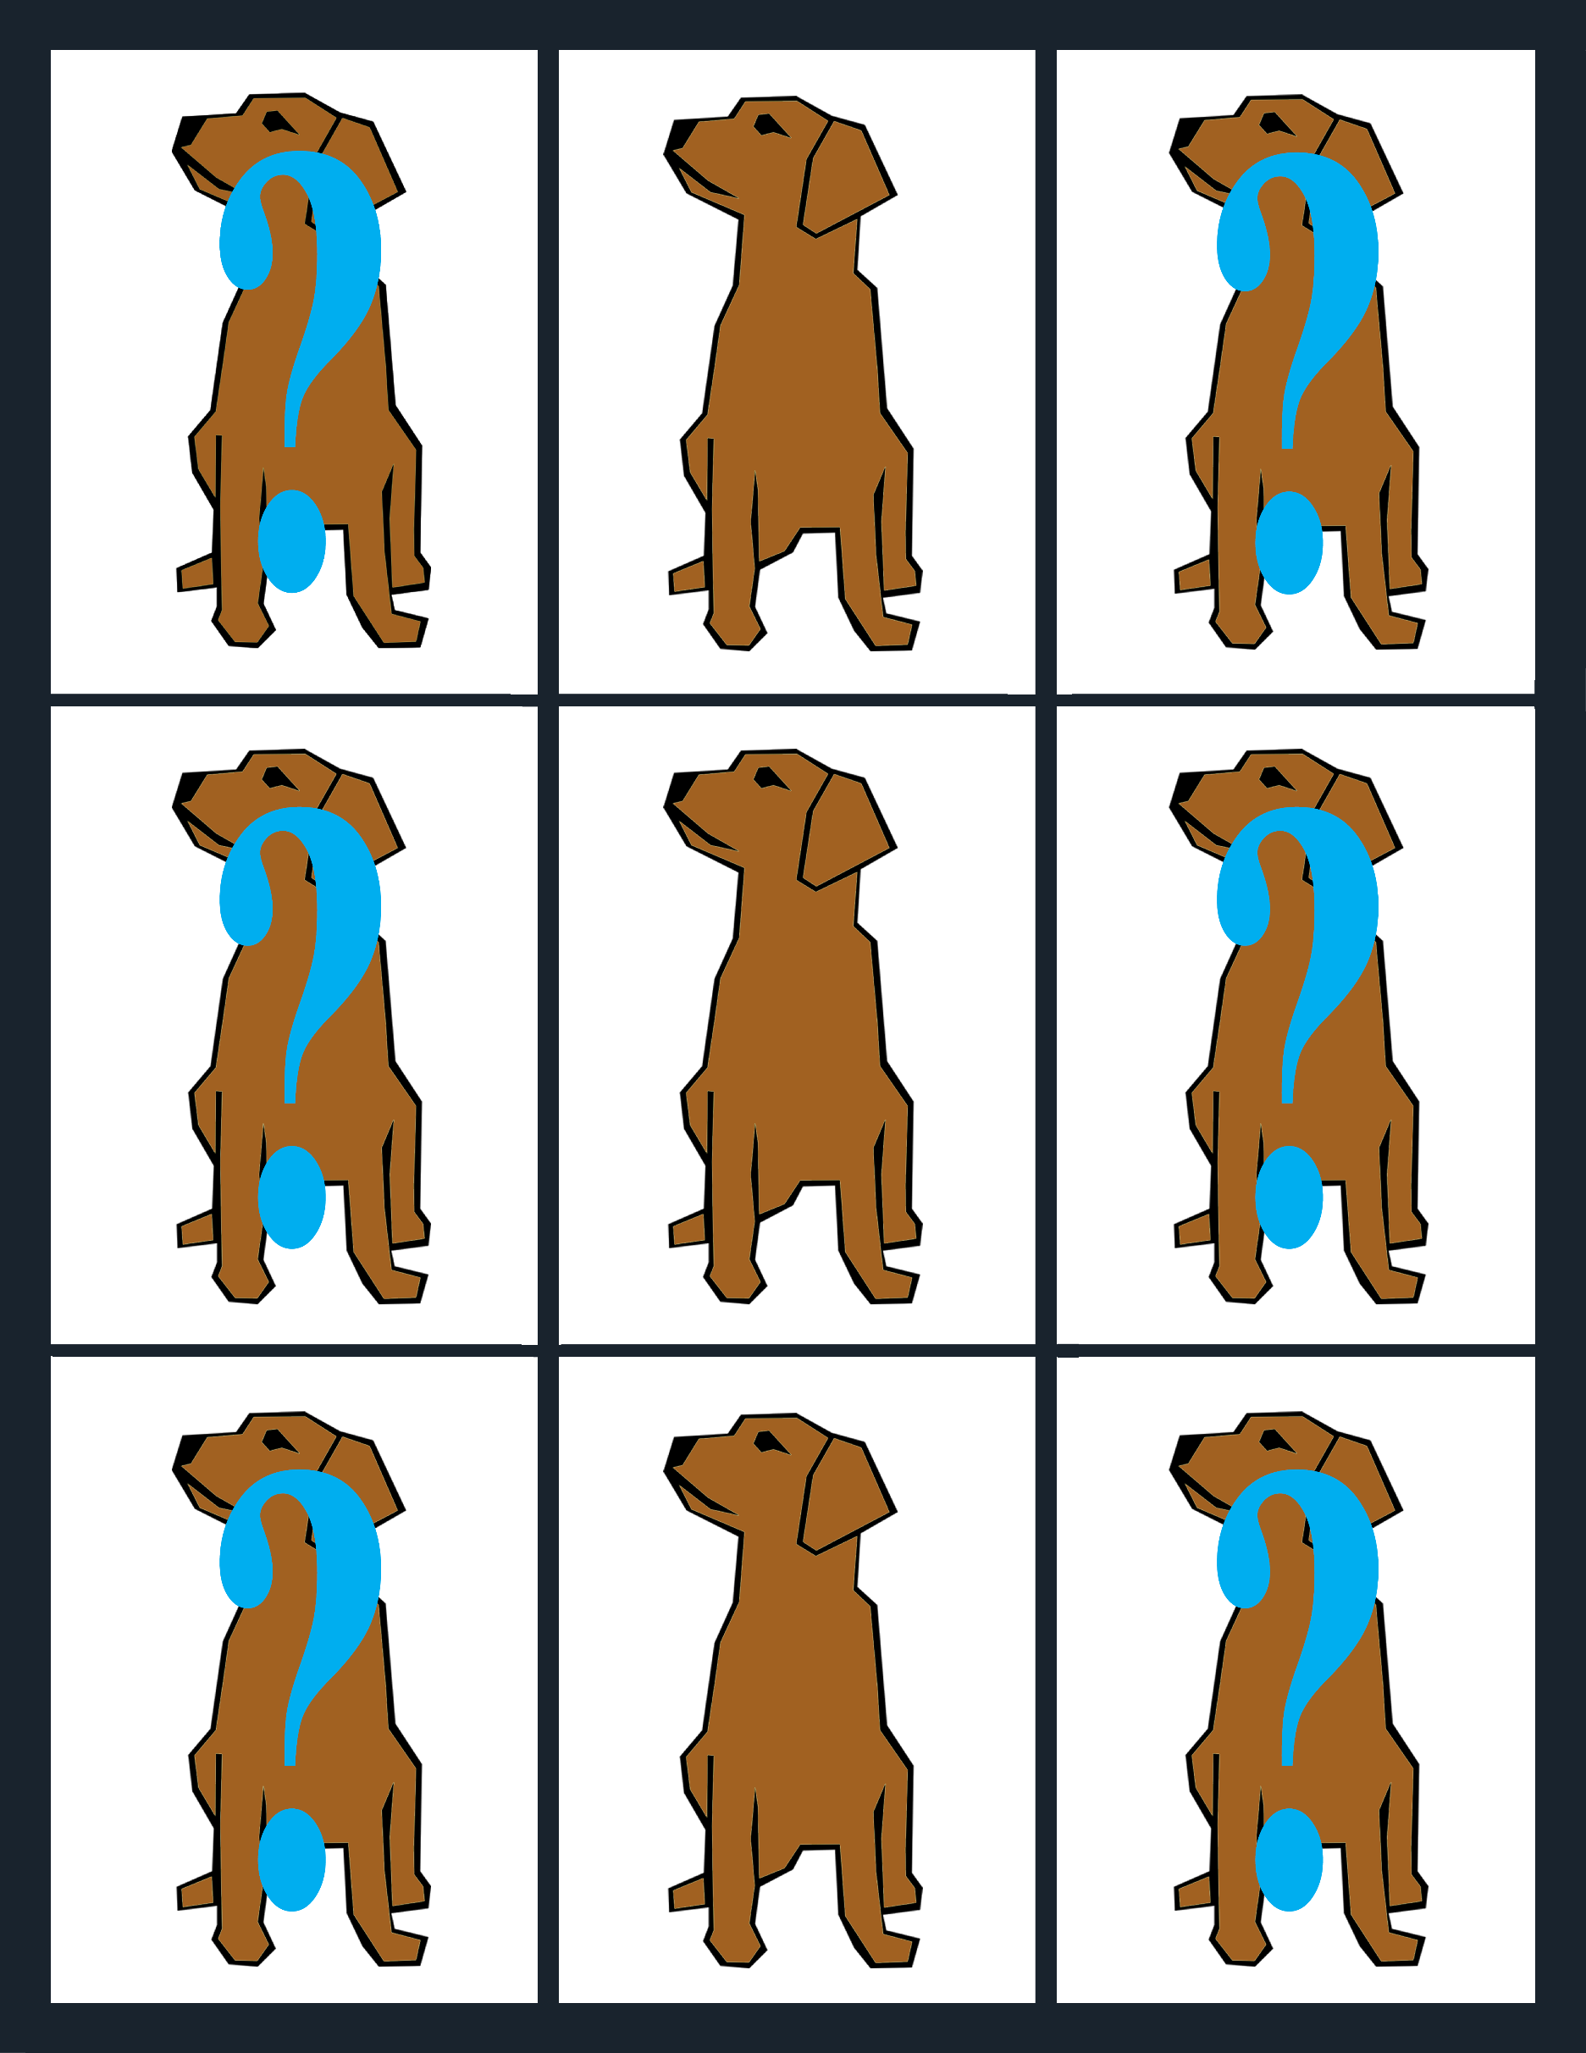
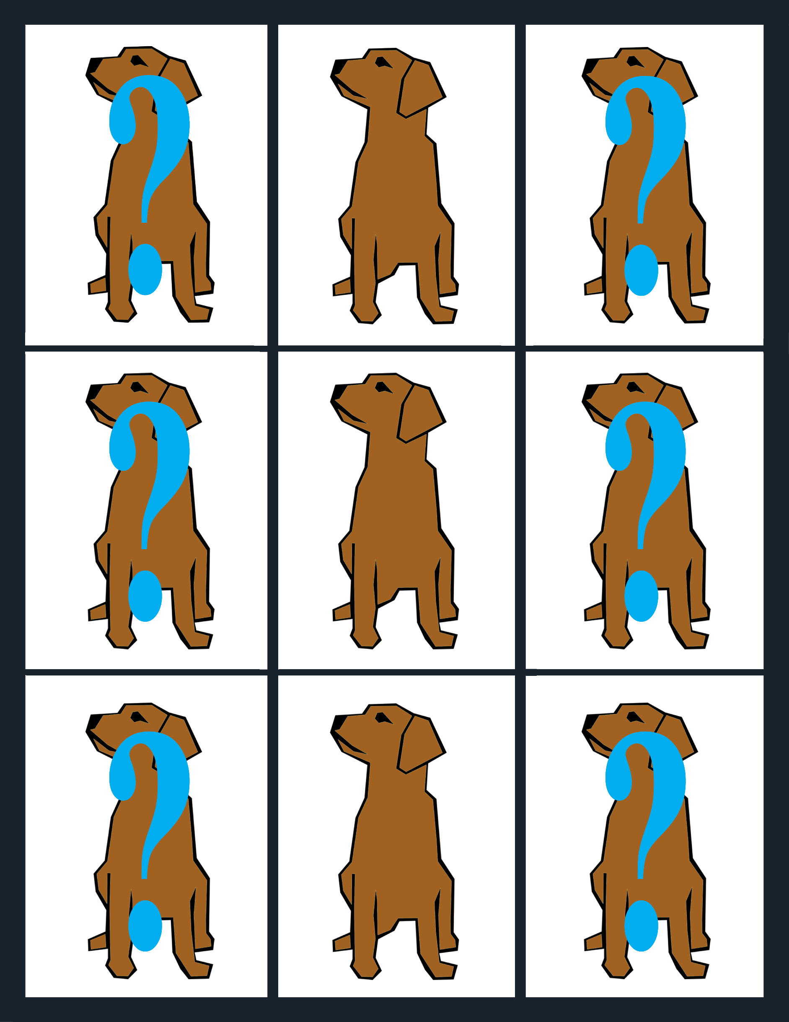

Terms of Use

DOG ON A LOG Printables are made available free of charge for educational purposes.
You may:
- Use them in a home, group, or school setting.
- Place a link to them on your website. www.dogonalogbooks.com/printables
- Create individualized game cards using the supplied Word and PDF files.

You may NOT:
- Use the Tup or other copyrighted images except in the personalization of educational game cards.
- You may not sell or distribute DOG ON A LOG Printables.
- You may not host them on your website or upload them to any other website or shared website.

Copyright ©2019 By Pamela Brookes
All Rights Reserved.
For information, contact the publisher at
read@dogonalogbooks.com

